2024-12-09

PINN Grazing experiment analyses DRAFT

- Table of permanova of all species in community. When we grouped into YAF, NAG, NPF, CAEX, CESO, NAF, DELO, YAG, ESCA, HIIN, LAGR, YPG and Dead the NMS had poor solutions and was therefore not used.
adonis2(formula = Wide_6 ~ Year * Treatment * SubTrt, data = Wide_6.env, permutations = 1000, by = "terms", parallel = 16, strata = Wide_6.env$Plot)
Df SumOfSqs R2 F Pr(>F)
Year 1 8.982 0.24473 94.8014 0.000999 ***
Treatment 2 0.639 0.01742 3.3746 0.001998 **
SubTrt 3 3.925 0.10695 13.8099 0.000999 ***
Year:Treatment 2 0.301 0.00821 1.5896 0.072927 .
Year:SubTrt 3 1.433 0.03903 5.0399 0.000999 ***
Treatment:SubTrt 2 0.128 0.00349 0.6760 0.569431
Year:Treatment:SubTrt 2 0.070 0.00190 0.3682 0.898102
Residual 224 21.224 0.57826
Total 239 36.702 1.00000

Interpretation: Year explains 24% of the variation in community composition and subtrt explains 11% of variation. All other covariates and interactions had no real effects on community composition.

- We used Generalized linear latent variable models (Niku et al 2019) with a negative binomial distribution along one axis to understand the effects of year, treatment, and subtreatment on percent cover (expressed as negative binomial counts) with a Plot level random intercept. The formula was:

gllvm(CoverData,
Enviromnetal Data,
family = "negative.binomial",
num.lv = 1,
formula = ~ Treatment + SubTrt + I(Year-2020) + (1|Plot),
seed = 1234)

Residuals and qq-plots were randomly distributed and closely , followed the expected theoretical quantiles, respectively, indicating appropriate distributional fit (Fig S1). Use attached gllvmPlot and if you like gllvmPlotBySpecies files.
- Correlations between Species. We created an occurrence correlation matrix based on the residuals from a two dimensional ordination done in gllvm. See attached file “CorrPlot” for positive and negative correlations between species in the full dataset with no covariates.

References:
Niku, J., Hui, F. K. C., Taskinen, S., and Warton, D. I. (2019). gllvm - Fast analysis of multivariate abundance data with generalized linear latent variable models in R. Methods in Ecology and Evolution, 10, 2173-2182.

Supplement
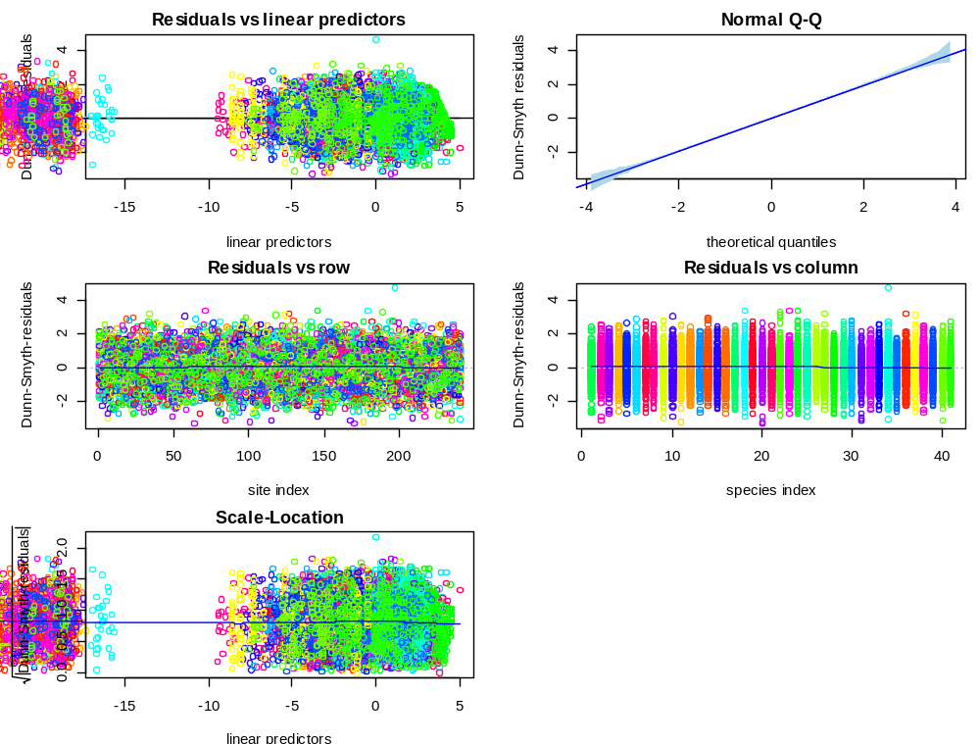
Figure S1. Residuals from gllvm model.

